CS 499 Module One Assignment

- Self-Introduction: Address all of the following questions to introduce yourself.

  - How long have you been in the Computer Science program?

I have been in the Computer Science program for two years now. In January of 2024 I took I took IT-140 Introduction to Scripting, my first class at SNHU.

  - What have you learned while in the program? List three of the most important concepts or skills you have learned.

Outside of the variety of languages I have learned, I have developed critical skills necessary to the practice of software development. Most critically is Object-Oriented Programming principles which have been interwoven throughout most of my coursework. Additionally, towards the end of learning how to develop full stack applications I have learned critical skills such as restful API’s and developing through the lens of designing a secure and scalable application by managing program development through key architectural decisions such as a implementing client-server distinctions. A third example of critical skills I have developed is learning to develop code which maximizes algorithmic efficiency and implement data structures which maximize efficiency through an understanding of Big O notation.

  - Discuss the specific skills you aim to demonstrate through your enhancements to reach each of the course outcomes.

This project will demonstrate the ability to develop a full stack application that will implement consistent secure coding practices and algorithmic efficiency. This project will involve migrating existing code into new frameworks and refactoring code to align with current industry standards. The overall goal of the project is to demonstrate the ability and motivation to learn new systems and design complete systems.

The starting point of this project is the android application developed for CS360 WeightSmart, a weight tracking application written in Kotlin that focuses providing in depth data visualization and analytical tools to its user. Following principles of Client – Server architecture, a server implementing Spring Boot in Java will act as the central API and will be used for Authentication and Authorization. The HAPI FHIR library will be deployed for standardization of medical terminology for long term scalability so that the application will work within the larger healthcare software ecosystem. The database layer will be developed in PostegreSQL with relationships being stored in optimal data structures such as usernames being stored in a B-tree to obtain O(logn) time complexity for username lookups. The first front end, the mobile app, will be transitioned to a MVVM (Model-View-VIewModel) design pattern. The mobile application will also store some data locally via local Rooms and will sync to the database whenever internet connection is available. An Angular SPA will be designed to function as admin portal for user management, billing, and system settings. This will be developed using an available free to use template for current time restraints of this project. Finally, an angular web application will act as an advanced dashboard for the user.

  - How do the specific skills you will demonstrate align with your career plans related to your degree?

This project will force me to use libraries and systems often found within healthcare
industry such as HAPI FHIR in Java and migrating the database to PostgreSQL. Developing a full stack application using industry standard systems and libraries is critical. This is the world I want to work in, as an individual who comes from working in healthcare I want to be responsible for designing systems that will drive improved patient and provider experiences, ultimately leading to improved patient outcomes.

  - How does this contribute to the specialization you are targeting for your career?

By developing a full stack application with a focus on security and data visualization tools, this application proves capability to develop full healthcare dashboards that can provide meaningful insight for clients. I chose a concentration in data analysis as I wanted to sit in the center of providing meaningful data analytics and meaningful software designs because I believe that providers and patients need to have convenient access and meaningful representation of their healthcare data to drive improved patient outcomes.

- ePortfolio Set Up:

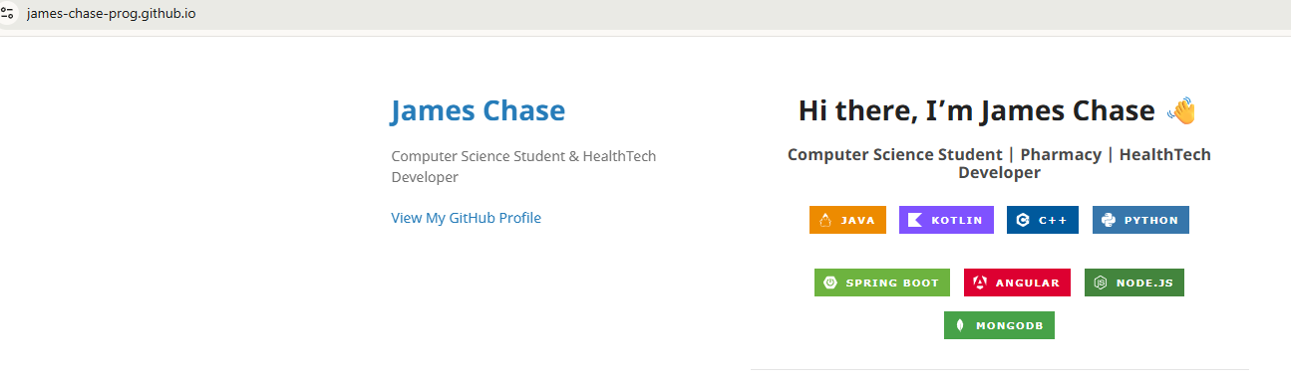
- Enhancement Plan:

  - Category One: Software Engineering and Design
    - Select an artifact that is aligned with the software engineering and design category and explain its origin. Submit a file containing the code for the artifact you choose with your enhancement plan.

From CS 360 the mobile application WeightSmart designed for android will be transitioned to a full stack application utilizing PostgreSQL, Angular SPAs executing MVC design, a Kotlin Android Application utilizing MVVM design, and a Java Spring Boot Server-side architecture to complete the Client - Server relationship.

    - Describe a practical, well-illustrated plan for enhancement in alignment with the category, including a pseudocode or flowchart that illustrates the planned enhancement.

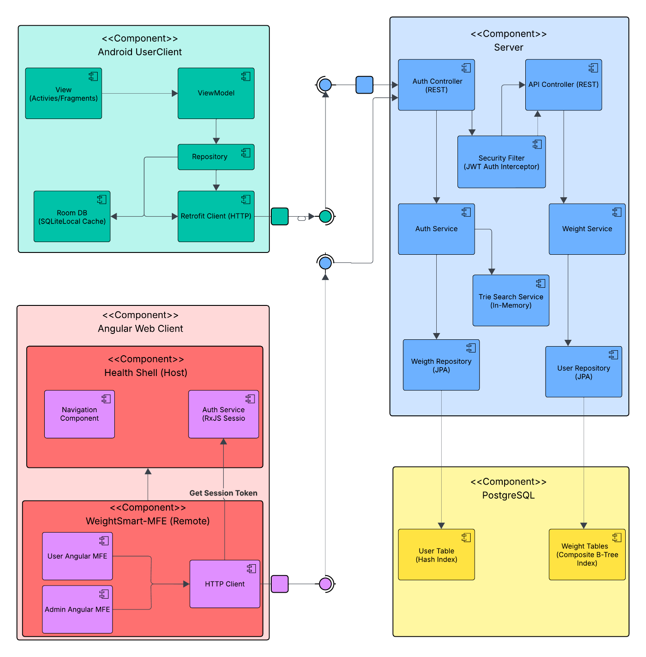
The WeightSmart Android Monolith will be refactored into a distributed full-stack ecosystem. The Android Kotlin application will be migrated from a local-only persistence model to a MVVM (Model View ViewModel) design pattern which interacts with a central Java Spring Boot API. Web presence will be built using Nx Monorepo with Module Federation designed with a “Health-Shell” as the host and dedicated WeigthSmart Micro-frontends (MFEs) for both the User Dashboard and the Admin Dashboard using Angular. Data will be stored within two PostegreSQL data tables for User data and Weight data which will be accessed by the Sprint Boot server side.
Android User Client (MVVM)

- View (Activities/Fragments): Presentation layer where users interact with weight entry forms, weight data tables, and charts.
- ViewModel: Logic hub that manages the state of the View and decides when to pull data from local storage or the network.
- Repository: Orchestrates data between the local Room DB (SQLite) for offline access and the Retrofit Client for remote server synchronization.

Angular Web Client (Micro-Frontend Architecture)
- Health Shell (Host): The main container that handles global navigation and provides the Auth Service (RxJS Session) to the rest of the application.
- WeightSmart-MFE (Remote): A modular remote entry containing the User Angular MFE and Admin Angular MFE. This design allows the administration portal and user dashboard to be developed and deployed independently while sharing a single shell for a unified user experience.

Server Boundary: Application Tier
- Security Filter (JWT Auth Interceptor): Intercepts incoming requests from the API Controller, validating the digital signature of the JWT to ensure the user is authenticated before allowing access to weight data.
- Auth Controller & Service: Manages registration and login
- Trie Search Service (In-Memory): An optimized data structure that provides O(L) time complexity user look-up
- API Controller & Weight Service: Handles the heavy lifting of user data including analytical calculations. It relies on the Security Filter to provide the specific userId extracted from the session token.
Database Boundary: PostgreSQL
- User Table (Hash Index): Optimized for O(1) constant-time lookups during the login process, allowing for near-instant credential verification regardless of the number of users in the system.
- Weight Tables (Composite B-Tree Index): Uses a multi-column index on (user_id, measured_at) to ensure that weight history for a specific user can be retrieved pre-sorted by date at O(log n) time complexity.
Interactions and Connections
Connection | Protocol / Pattern | Purpose
Client to Server | REST / JSON | The frontends communicate with the API via Retrofit (Android) or HTTP Client (Angular) using JWTs for stateless session management.
Server to Database | JPA / Hibernate | The server uses Object-Relational Mapping to interact with PostgreSQL, abstracting the raw SQL queries.
Identity Flow | Prefix Search | The Auth service utilizes the in-memory Trie to provide fast user-discovery feedback without hitting the disk-based database.
Data Flow | Index-Optimized Retrieval | The Weight service queries specific shards of the B-Tree to fetch historical data for graphs and exports.

Data Flow Sequence: Authenticated Weight Sync
- Actor: User submits a new weight entry on the Android Client.
- Android UI (View): Forwards the data to the ViewModel.
- ViewModel: Calls persistWeight() on the Repository.
- Repository: Immediately saves the entry to the Room DB (Local Cache)
- Repository: Forwards the entry to the Retrofit Client to sync with the server.
- Spring Boot (Security Filter): Intercepts the request and decodes the JWT to extract the userId.
- Spring Boot (Weight Service): Receives the userId and the entry
- Spring Boot (JPA Repository): Persists the data to the PostgreSQL Weight Table using the Composite B-Tree Index.
- PostgreSQL: Returns a success confirmation back up the chain.

    - Explain how the planned enhancement will demonstrate specific skills and align with course outcomes.

      - Identify and describe the specific skills you will demonstrate that align with the course outcome.

- Software Design & Architecture: Implementing a Micro-Frontend architecture using Nx Monorepo and Module Federation demonstrates the ability to design scalable modular web systems.
- Mobile System Design: Developing using a MVVM design pattern in Android with Room DBN demonstrates an ability to develop applications using modern mobile application standards.
- Full-Stack Development: Demonstrates the ability to transition a locally persisted android application to Client – Server Architecture full stack program utilizing critical programming principles are creating scalable modular designs.
- Secure Coding: Implementing a JWT (JSON Web Token) Auth Interceptor and a Security Filter to sanitize and authorize every incoming request demonstrates a commitment to building secure, industry-standard client-server relationships.
- System Integration: Designs a system connecting disparate platforms (Android, Angular, and Sprint Boot) through a unified REST API

      - Select one or more of the course outcomes below that your enhancement will align with.

- Outcome 1: Designing a full system with well-designed and documented architectural component diagrams sets the foundation for enabling various software engineers with diverse expertise and backgrounds to contribute towards development of a larger project.
- Outcome 2: Through the creation of high-fidelity Component diagram and detailed data flow sequence description that map complex interactions like the "Authenticated Weight Sync," I am demonstrating the ability to convey intricate architectural plans to technical and non-technical stakeholders.
- Outcome 3: The transition from a local-only monolith to a distributed system utilizing Java Spring Boot, Angular, and Kotlin reflects the delivery of professional-grade software solutions.
- Outcome 4: The use of Nx Monorepo, Module Federation, and Retrofit represents the adoption of modern, industry-leading tools and workflows used in contemporary software engineering.
- Outcome 5: The architecture prioritizes data protection via stateless session management, JWT validation, and the abstraction of raw database queries through JPA to prevent SQL injection and unauthorized access.

  - Category Two: Algorithms and Data Structures

- Select an artifact that is aligned with the algorithms and data structures category and explain its origin. Submit a file containing the code for the artifact you choose with your enhancement plan. You may choose work from the courses listed under Category One.

From CS 360 the mobile application WeightSmart designed for android the login and user registration a process will be overhauled. Currently, the application relies on inefficient linear database scans for searching and standard library sorting methods for display. As users are registering, a optimal search-as-you-go” system for username availability will be implemented via a Prefix Tree (trie) data structure in the server’s heap memory. This allows users to identify available usernames and login in at O(L) time complexity.

- Describe a practical, well-illustrated plan for enhancement in alignment with the category, including a pseudocode or flowchart that illustrates the planned enhancement.

By storing existing usernames in the server’s heap memory within a Prefix Tree (Trie), the registration experience is enhanced through an optimized “search-as-you-go” system which provides real-time feedback on username availability with a O(L) time complexity. This means that regardless of the number of users, the registration and username look-up have an O(L) time complexity, where L is the length of the username, compared to the previous linear look-up speed of O(N). By migrating this logic to the Java Spring Boot server's heap memory, we replace disk-heavy scans with memory-resident character traversal.
A Trie is a specialized tree-based data structure used for retrieval. Each node in the Trie represents a single character of a username. Instead of storing full strings repeatedly, the Trie stores the shared prefixes of all usernames. To check if "User1" is available, the algorithm starts at the root and follows the pointers for 'U' -> 's' -> 'e' _> 'r' -> '1'. If at any point the path breaks, the username is confirmed as available. If the path is complete and the final node is marked with an isEndOfUsername flag, the name is taken. The Trie will use lazy initialization where child nodes and character maps are only instantiated when a specific path is created to minimize the heap footprint.
Security concerns for a Trie include exposure to brute force attacks to verify all existing username and Denial of Service attacks. A Token Bucket Rate Limiter algorithm will be implemented at the /check-availability endpoint to limit checks from a single IP to 10 checks per minute to prevent an Enumeration attack. Implementing a server enforced strict length constraint prevents excessively long usernames from passing the security filer level and entering the Trie search to as a Max-Depth guard. These two combined will help prevent against denial of service-based attacks.

Psuedocode: Username Availability Check
FUNCTION isUsernameAvailable(inputName, clientIP):
// SECURITY: Prevent automated harvesting via Token Bucket
IF NOT RateLimiter.hasTokens(clientIP):
RETURN ERROR_429_TOO_MANY_REQUESTS

// SECURITY: Prevent deep-traversal/DDoS attacks via Length Guard
IF inputName.length > MAX_USER_LENGTH:
RETURN ERROR_400_INVALID_INPUT

currentNode = root
FOR char IN inputName:
// If the character path does not exist, the name is available
IF NOT currentNode.children.contains(char):
RETURN TRUE
currentNode = currentNode.children[char]

// Check if the completed path represents a registered user
// IF isEndOfUsername is true, the name is TAKEN (NOT available)
RETURN NOT currentNode.isEndOfUsername
- Explain how the planned enhancement will demonstrate specific skills and align with course outcomes.

  - Identify and describe the specific skills you will demonstrate to align with the course outcome.

- Algorithmic Optimization: Demonstrates the ability to replace an inefficient O(N) linear scan with an O(L) path traversal
- Data Structure Implementation: Implements and manages specialized memory-resident structures like the Trie with lazy initialization to balance performance and heap utilization
- Secure Coding: Demonstrates a security mindset by wrapping algorithms in protective layers such as the Token Bucket Rate Limiter

  - Select one or more of the course outcomes listed under Category One that your enhancement will align with.

- Outcome 3: The implementation of an optimized Trie represents a high-performance, professional solution for real-time data validation.
- Outcome 4: Utilizing server-side heap memory and advanced data structures reflects a sophisticated approach to software engineering.
- Outcome 5: Directly addressing brute-force and DoS vulnerabilities through rate limiting and length guards demonstrates a proactive approach to software security.

  - Category Three: Databases

    - Select an artifact that is aligned with the databases category and explain its origin. Submit a file containing the code for the artifact you choose with your enhancement plan. You may choose work from the courses listed under Category One.

From CS 360 the mobile application WeightSmart designed for android. In its current state, the application utilizes Android Room, an abstraction layer over SQLite, to store user credentials and weight data locally on the user's device. The Data Layer will be migrated from the local Android SQLite architecture to a distributed Client-Server Relational Model hosted on PostgreSQL. A hybrid indexing strategy will be deployed within PostgreSQL via a Hash Index to the username column of the user’s data table and a Composite B-Tree on user_id and measured_at on the weights data table. Upon login, the weight database is read, and all user weights are written into the SQLite Room allowing offline functionality. As new records are added, the system will synchronously update both the Server-side PostgreSQL database and locally stored Room.

    - Describe a practical, well-illustrated plan for enhancement in alignment with the category, including a pseudocode or flowchart that illustrates the planned enhancement.

Data storage will be migrated from locally persisted data with Android Rooms and local storage on the user devices to implementing a data layer as part of a larger full stack development by implementing a PostgreSQL database with two data tables for users and weights. A hybrid indexing strategy will be employed across the two data tables and a Bi-directional synchronization logic will be implemented between the Android client and the Spring Boot server.
For the username column, a Hash Index is utilized. This provides O(1) constant-time lookups, which is optimal for the exact-match queries used during the login and authentication process. For the weights data table, a Composite B-Tree Index is applied to the (user_id, measured_at) columns. This allows the database to perform efficient range scans and retrieve a specific user's weight history in pre-sorted order at O(log n) time complexity.

Data Model (DDL Implementation)
-- USER TABLE: Optimized for O(1) Authentication
CREATE TABLE users (
user_id SERIAL PRIMARY KEY,
username VARCHAR(30) UNIQUE NOT NULL,
password_hash TEXT NOT NULL,
password_salt TEXT NOT NULL,
email VARCHAR(100) UNIQUE NOT NULL
);

-- THE HASH INDEX: The core of the O(1) lookup skill
CREATE INDEX idx_user_auth_hash ON users USING HASH (username);

-- WEIGHT TABLE: Optimized for O(log n) History Retrieval
CREATE TABLE weights (
weight_id SERIAL PRIMARY KEY,
user_id INT REFERENCES users(user_id) ON DELETE CASCADE,
weight_value NUMERIC(5, 2) NOT NULL,
measured_at TIMESTAMP DEFAULT CURRENT_TIMESTAMP NOT NULL
);

-- THE COMPOSITE B-TREE INDEX: The core of sorted range scans
CREATE INDEX idx_user_weight_history_btree ON weights (user_id, measured_at DESC);

ERD Diagram
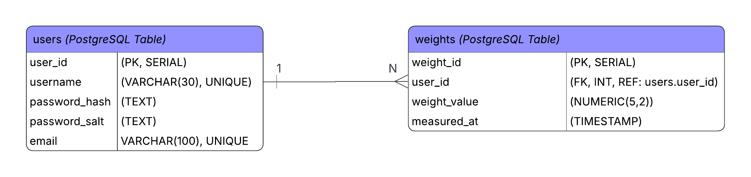

Query Execution Map
Scenario | Application Query | Database Execution Strategy | Performance Goal
User Login | SELECT * FROM users WHERE username = 'jsmith'; | Index Scan (Hash): The engine jumps directly to the memory address of the username. | O(1)
History View | SELECT * FROM weights WHERE user_id = 101 ORDER BY measured_at DESC; | Index Range Scan (B-Tree): The engine finds the user_id and reads the pre-sorted list of weights. | O(log n)

Upon a successful login, the system queries the PostgreSQL database via the API. All historical weights are downloaded and written into the local SQLite Room database. When a user adds a new weight, the Repository performs a synchronous update: it writes to the local Room DB immediately for instant UI feedback and simultaneously pushes the record to PostgreSQL via the Spring Boot API.

Pseudocode: Bi-Directional Synchronous Update
FUNCTION persistWeightEntry(newEntry):
// STEP 1: Immediate Local Persistence (Room)
roomDatabase.weights().insert(newEntry)
updateUI("Entry saved locally")

// STEP 2: Remote Persistence (PostgreSQL via API)
TRY:
response = retrofitClient.syncWeight(newEntry)
IF response.isSuccessful():
markAsSyncedInLocalCache(newEntry.id)
CATCH NetworkException:
// Resilience: Schedule background sync for later
WorkManager.scheduleSync(newEntry)
    - Explain how the planned enhancement will demonstrate specific skills and align with course outcomes.

      - Identify and describe the specific skills you will demonstrate that align with the course outcome.

- Distributed Systems Engineering: Demonstrating the ability to migrate a local-only monolith to a professional N-Tier architecture with distributed data persistence.
- Database Optimization: Proving mastery of relational indexing by matching specific algorithms (Hash vs. B-Tree) to their ideal use cases (Exact Match vs. Range Scan).
- Data Integrity & Concurrency: Implementing synchronization logic that ensures consistency between local SQLite caches and remote PostgreSQL instances.
- Offline-First Architectural Design: Designing a system that maintains high availability for the user during network disruptions while guaranteeing eventual consistency with the server.
      - Select one or more of the course outcomes listed under Category One that your enhancement will align with.

- Outcome 3: The implementation of a multi-indexed relational model represents an industry-standard approach to data management.
- Outcome 4: Transitioning to PostgreSQL represents a transition to an industry standard database solution for health-data.

- ePortfolio Overall Skill Set

  - Accurately describe the skill set to be illustrated by the ePortfolio overall.
    - Skills and outcomes planned to be illustrated in the code review

The code review will focus primarily on detailing the current state of the CS 360 android Kotlin monolith with a focus on weaknesses in data persistence, security, and development of scalable, updatable code. By detailing the existing code and identifying areas for improvement and enhancement, the ability to identify technical debt and create actionable plans to improve systems is demonstrated. Logic behind where different computational logic is stored, client vs server, will be explored within a code review, highlighting and understanding of developing code that is user and memory friendly. Describing current code strengths and weaknesses will prove an ability to convey complex design trade-offs, such as the memory-for-speed trade-off involved in heap-resident data structures. Overall, the code review acts as an opportunity to focus on course outcomes 1 and 2. Dictating code is critical for helping others understand your code’s functionality and can lead to process improvements. It is critical to be able to professionally explain the functionality of a program to others as part of a larger effort to develop effective communication and documentation around software programs.

    - Skills and outcomes planned to be illustrated in the narratives

The narratives across the three categories illustrate a mastery of software design, innovative tool integration, and advanced security practices. The Software Engineering narrative details the use of an Nx Monorepo and Module Federation to orchestrate multiple Micro-frontends (MFEs) under a "Health-Shell," ensuring a unified user experience with independent deployment cycles. The Algorithms narrative focuses on the transition from O(N) linear database scans to a high-performance Prefix Tree (Trie) structure, achieving O(L) constant-time lookups while implementing Token Bucket rate limiting to defend against enumeration attacks. Finally, the Databases narrative showcases a Hybrid Indexing Strategy in PostgreSQL, utilizing Hash Indexes for O(1) authentication and Composite B-Tree Indexes for O(log n) chronological retrieval of weight history.

    - Skills and outcomes planned to be illustrated in the professional self-assessment

The self-assessment acts as an opportunity to reflect on where capstone program has taken the artifacts of choice or in this case how close the capstone program has taken the CS 360 mobile app towards an efficient functional full stack application. By clearly assessing my work and distributing a detailed e-portfolio on the capstone project, I will have to practice effective communicating with stakeholders on the full functionality, strengths, weaknesses, obstacles, and threats the now full stack WeightSmart application. Having taken a substantial challenge to move a mobile app to a full multiple front end full stack application on a unfamiliar database system while implementing optimal search algorithm, the self-assessment will provide me the opportunity to demonstrate my skill in data structures, algorithms, software engineering, databases, and security. Finally, the self-assessment gives me the opportunity to find additional areas for improvement and reflect on areas that I could have optimized my work.

